Game Design Document

Fill up the following document

1. Write the title of your project.

Catch me if you can

1. What is the goal of the game?

Main character has to defend itself through all the obstacles

1. Write a brief story of your game.

There is a ball in the middle of the canvas, four obstacles are there in the four corners of the canvas to block the way of the ball.

The ball has to defend itself from the moving obstacles and if it collides with the obstacles, the game starts again.

1. Which are the playing characters of this game?

* Playing characters are the ones who respond to the user based on the input from the user.
* Cars, monkeys, dinos, wizards, etc., are the playing characters in the game.

|  |  |  |
| --- | --- | --- |
| Number | Character Name | What can this character do? |
| 1 | whiteBall | It just has to defend itself from the obstacles in its way, it will be in its normal position just has to move right,left,up and down. |
| 2 |  |  |
| 3 |  |  |
| 4 |  |  |
| 5 |  |  |
| 6 |  |  |
| 7 |  |  |
| 8 |  |  |

1. Which are the Non-Playing Characters of this game?

* Non-Playing characters are the ones that don't have an action or behavior when the user interacts with the game.

Hurdles, stones, bananas, coins, etc., are non-playing characters in the game.

|  |  |  |
| --- | --- | --- |
| Number | Character Name | What can this character do? |
| 1 | Dark Spikers | They are spikes on the upper and the lower position of the canvas, ones the ball touches the them, it will explode |
| 2 | Lasers | They are moving obstacles from which the ball has to defend itself, and as the game goes on, the veocity of the obstacles will increase. |
| 3 | Bullets | It will come from anyside randomly |
| 4 |  |  |
| 5 |  |  |
| 6 |  |  |
| 7 |  |  |
| 8 |  |  |

Draw your imagination of this game. What does this game look like?

* Draw the game either on your computer or on paper.
* Add images of the game scenes to show each of the playing and non-playing characters at least once.

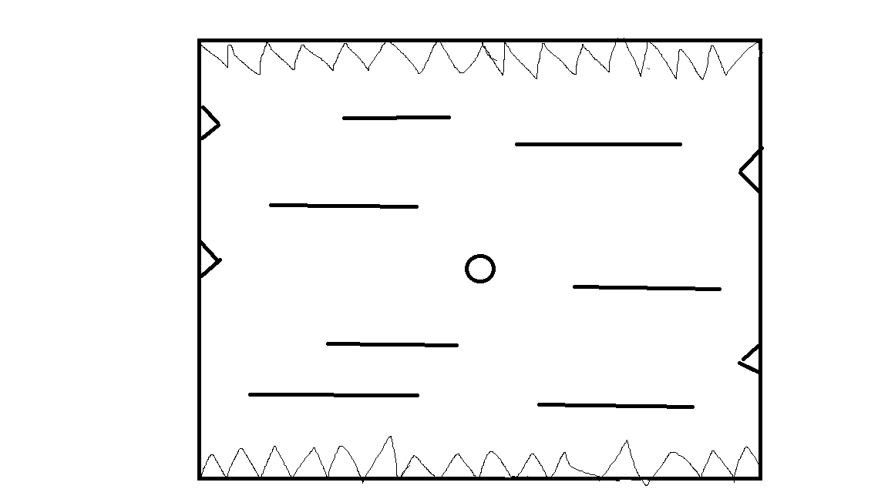

How do you plan to make your game engaging?

As the game goes on, the velocity of the moving lasers increases and some of the spikes randomly will start moving anytime and then again stop and then also if the ball manages to protect it self then bullets will start appearing from anytime and anywhere.